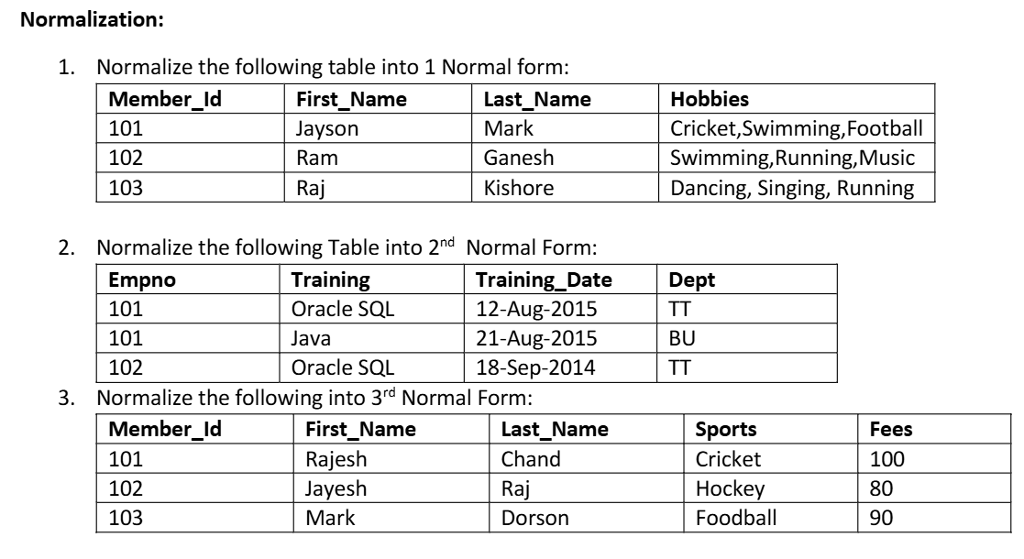

Answer :-
1.) Normalization in 1NF
Member_Id | First_Name | Last_Name | Hobby
101 | Jason | Mark | Cricket
101 | Jason | Mark | Swimming
101 | Jason | Mark | Football
102 | Ram | Ganesh | Swimming
102 | Ram | Ganesh | Running
102 | Ram | Ganesh | Music
103 | Raj | Kishore | Dancing
103 | Raj | Kishore | Singing
103 | Raj | Kishore | Running

2.) Normalization in 2NF
The given table is already in 2NF because there is no functional dependency in given table.
3.) Normalization in 3NF
Member_Id | First_Name | Last_Name | Sport
101 | Rajesh | Chand | Cricket
102 | Jayesh | Raj | Hockey
103 | Mark | Dorson | Football

Sports | Fees
Cricket | 100
Hockey | 80
Football | 90

